**Daniel Williamson**

**Project #10**

**5/2/16**

**CS 200**

Project Overview

Purpose:

The purpose of this project was to create a recursive maze generator in assembly. Essentially we are tunneling our way through a maze two steps at a time in a random direction and then repeating over and over again until all the space has been consumed. If it is about to cross itself, you go to another level of recursion to see if another direction is possible. If there is, you continue tunneling, if there is not your tunnel is complete.

Approach:

To begin this project, I immediately referred back to project #9’s code which is where we did all our testing. After Friday, I also took a gander at the posted skeleton code from yourself. Unfortunately, neither were much help. So I took to the internet and jumped into this project blindly. I knew I was using recursion and that was about it. I tried my hardest to understand the C++ code but, severally things, such as the local array and the recursion were extremely difficult to understand. So, I reused my code from project #9 and began working. I knew I had to begin with giving the direction to the drill for tunneling. However, as you will find out, I couldn’t get it to go further than 2 steps.

Results

These are my results:

This is a depiction of North and South, essentially what they do, is store the x and y values of the grid and checks to see if they are within bounds. Then it will “drill” north or south and remove the #’s.

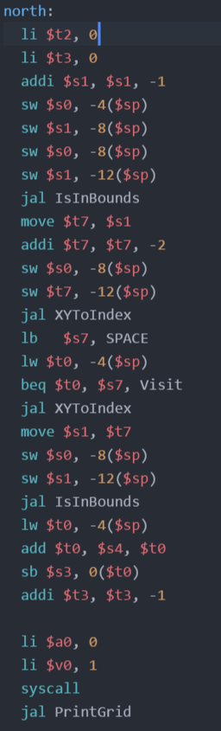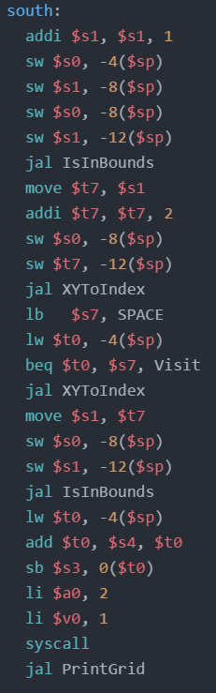

This is a depiction of East and West, essentially what they do, is store the x and y values of the grid and checks to see if they are within bounds. Then it will “drill” east or west and remove the #’s.

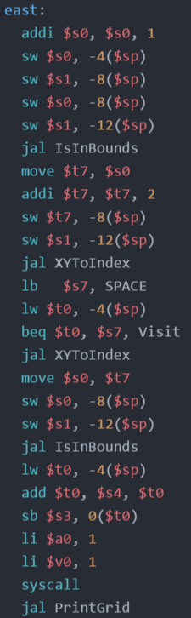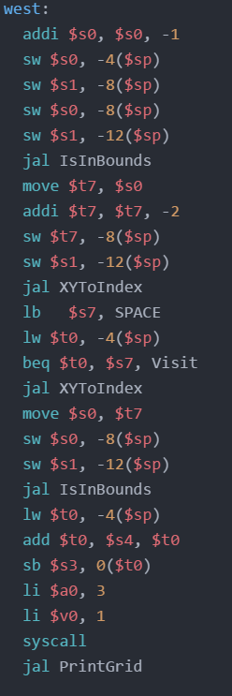

Testing:

Unfortunately, you are probably well aware by now my code is not working properly. All I was capable of making happen wasn’t a whole lot. As seen in the depiction the code fails to make a maze. I could only get it to remove two pound symbols.

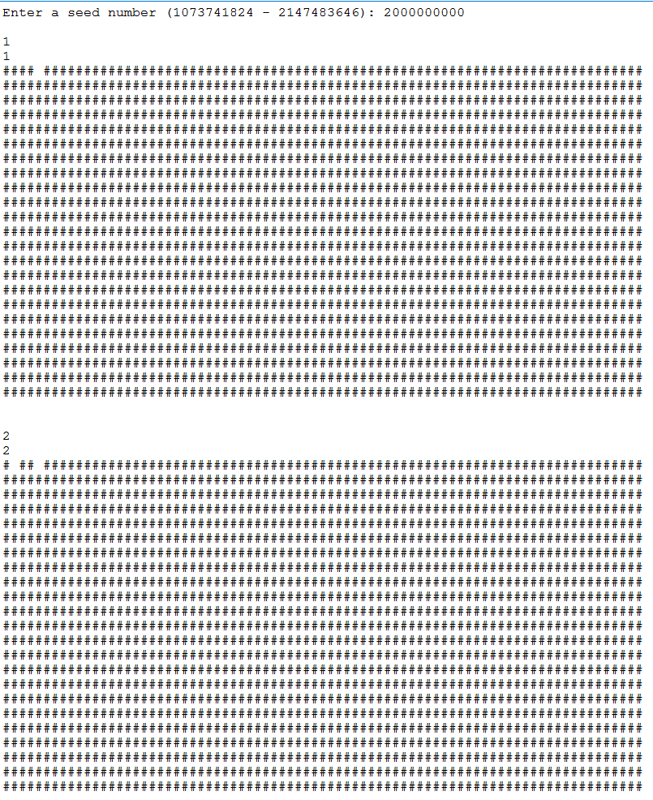

Conclusion

In conclusion, this project was a failure. I spent many hours searching the internet and reading over our book for better insight on how to solve my problem. Even speaking with my peers, I could not cohesively correct my wrong doing. This project, by far, has been the most difficult project to date. It has come to the point where I either submit what I have or continue burning time on this project and possibly not even complete it. Most, if not all, of my peers have been struggling with this lab. I implore you to see it in yourself to go as easy as you can on this project. If I simply had more time maybe I could finish this. The problem I am having, I believe, is the recursion is just not quit working. After multiple attempts at trying to address this, ended in failure and I can’t quit get it right. Not to mention, I can’t seem to keep it within the bounds of the grid. No matter what I did to fix these, nothing would work.